Send to potential express party hosts:
Our annual Tupperware Recordbreaker is just around the corner. I'm working to break my record. We have incredible offers for Hosts. I'm wondering if you'd host an "express party" with me? It's as simple as sharing a few messages and a shopping link. Would you like some details?

Once host responds:
Here's how it works I create a few messages for you to share with friends. Included will be a link to a demonstration, a personalized shopping link and a few incentives. All you do is send the messages to 20-30 friends via your preferred way of communicating(text, messenger or email) and pick your gifts by Oct 4th! Whatcha think?

When she says yes,
Can you send me your email, phone and shipping address so I can get it set up

send message 1
I’ll mail you an envelope that has a full line catalog, our October specials, and two Host Gift Sheets. These are for you to pick your gifts. Here’s a few tips:

Step 1: Make a list of what you’d like for free and half off. You will qualify based on your total sales. You'll get a gift just for saying YES and more starting at $200

Step 2: Make a list of people that love Tupperware or love to cook or eat...lol. Don’t get discouraged when some decline. Only ¼ of those on your list will be interested in shopping

Step 3: Personally invite them. Be excited and personally invite your family and friends to shop by sending them the message I’ve provided. I recommend that you not send one big massive text, but an individual text. Feel free to personalize it a little. Final date for party orders: I will need to close your party no later than Oct 4th. If your friends are procrastinators, you should tell them the 3rd lol.

Step 4 Have 2 bookings! Line up 2 of your family and friends who will have a party of their own and I will shower THEM with free products! It will also increase your Host awards!
Here's something to text or message your friends:

Followed by message 2
Hi! Hope you’re doing well! Fall is here and I know everyone is starting to think about the holidays. I’m hosting an online Tupperware party to snag some great products. It’s a super easy party since everyone is so busy...all done via a few messages I’ll send you, along with a shopping link. Are you interested?

Followed by message 3
If you get a no, just thank them and move on. When you get a yes, here's what to send:

Followed by message 4
Great! Here’s a link to an online catalog, along with the current sales specials. https://www.legacypartysales.com/catalog-and-specials/

My consultant is doing a drawing among everyone that places an order by Tuesday. To enter, just text her a screen shot to 8088591469, and let her know you’ve ordered with my party
Here’s my party link:

Optional message:
If you like to see things live, instead of pictures, here’s a video of some of the sales specials:

A day after they’ve been inviting:
I'd invite a group first, and then use this to scoop up people you might have missed.
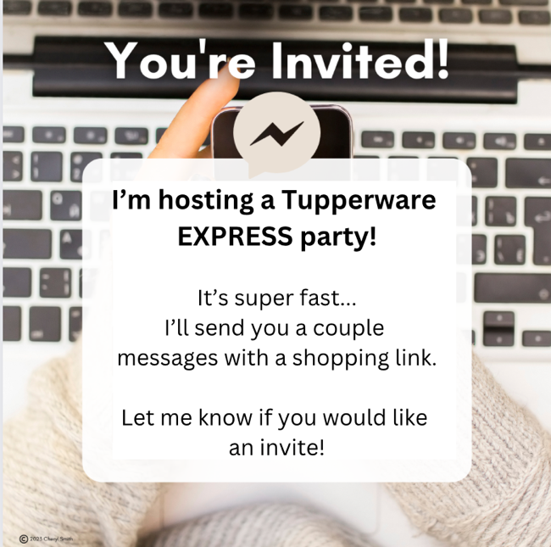

A few days after mailing the packet:
Hi! Just want to see if you received your catalog?

No matter what they say, send the jpg of the host gift sheet.

Next message
Let’s talk about your wish list. What’s on your list?

Next message
Which items would you like for your half off?

Next message:
Did you see the exclusive Host gifts? Pretend your qualified already. Which one would you choose?

Next message:
Did you see the double host credit offer at $1000? That’s about 20 orders. That would give you 400 Host Credits!!

Reminder message on Tuesday:
Just a quick reminder that we are going to close out your party on Wednesday. Today would be a great day to send out a reminder. People get busy and procrastinate. Here’s a message you can send:

Reminder:
Hi! Just a quick reminder that my online Tupperware party is ending tonight. If you haven’t placed an order yet, there’s still time. Here’s the link to an online catalog, along with the current sales specials. https://www.legacypartysales.com/catalog-and-specials/
Here’s my party link:

My consultant is doing a drawing among everyone that places an order by Tuesday. To enter, just text her a screen shot to ------------, and let her know you’ve ordered with my party.

Message each person that sent you a screenshot:
- Thank them for their order
- Invite them to host a party
- Invite them to your VIP group

After you’ve closed:
Thank you for being a part of my Recordbreaker! I appreciate your loyalty so much. I hope you enjoy your gifts and I look forward to partying with you again .

I highly recommend sending a handwritten thank you note to the host and to any customer placing an order of $100+

