***Meal Planning the Easy Way!***

Do you struggle with the day-to-day chore of meal planning?

Does 5 o’clock arrive   
and somehow you forgot   
to plan dinner?   
Let your ***TupperPal*** help!

Have your meals ready for when your busy schedule prevents preparing a healthy meal for you and your family!

Join us for a fun time where all the shopping, prepping, & cleanup will be done for you while we prepare 5 meals, all packaged and ready to take home in ***Tupperware***!

I am so excited to offer this service to you and your family, please contact me so we can get your Prep Session scheduled!

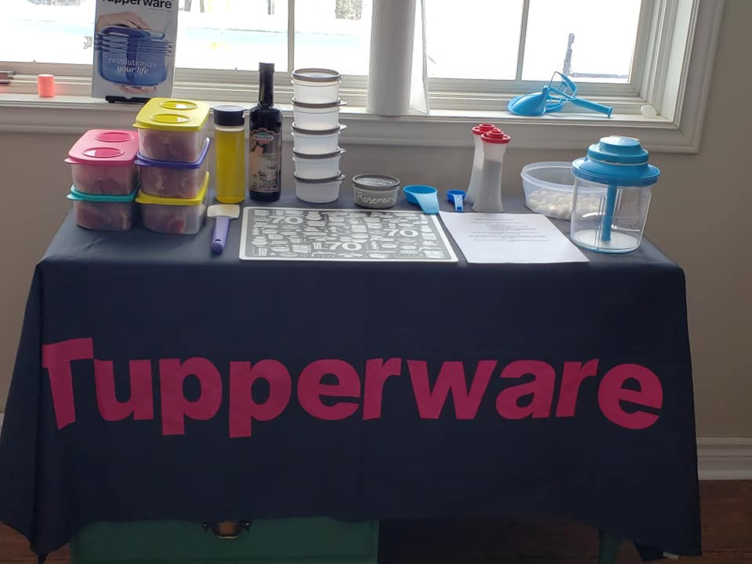

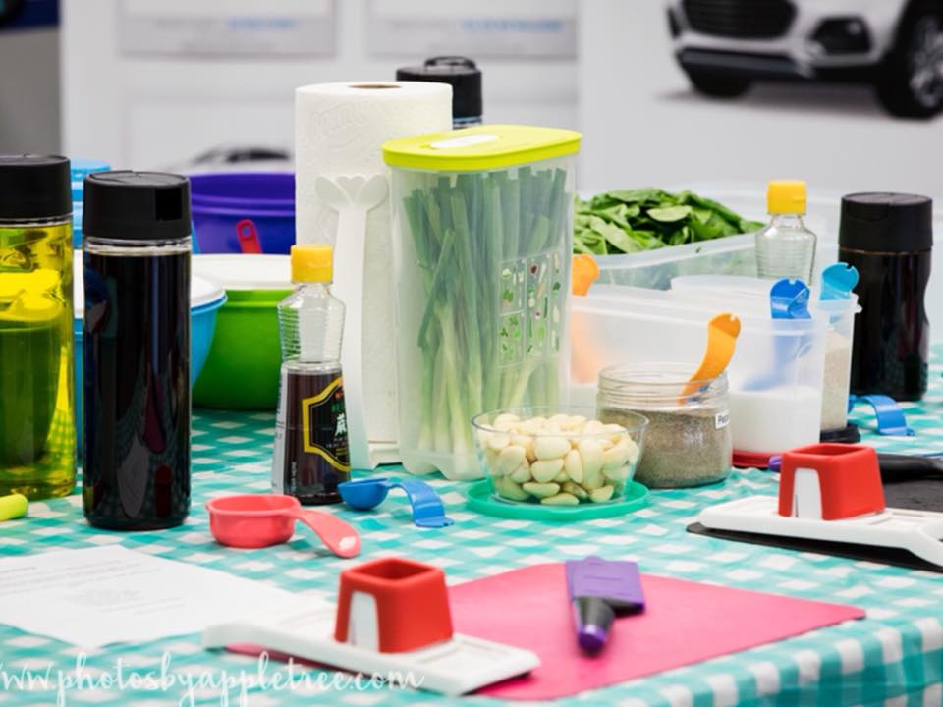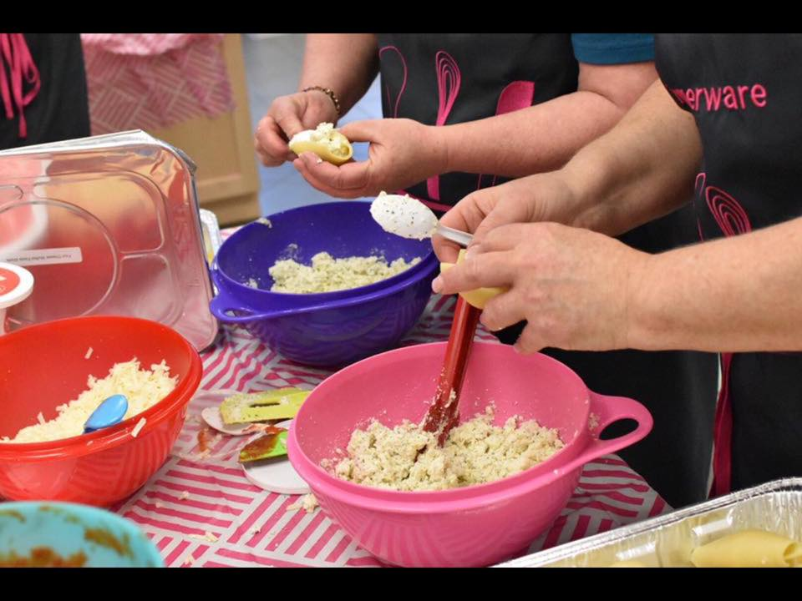

Meals  
 Made  
 Easy!

Let’s Do It!

Meal planning can be difficult, whether you lead a busy life, unpredictable schedule, or just aren’t sure where to start. We are here to help you!

Contact your ***TupperPal*** today!

**Registration and Cost**

***Registration includes:***

* A personal shopper to get all ingredients for your 5 meals
* Prepping all of the food
* We provide the spices and staples *(no buying a spice to use once)*
* Tupperware to transport   
  your meals home
* *NO DISHES!* Yes, we take care of the clean up too.
* $25 shopping credit from our catalog and sales specials

***COST***

***Family of 4 – Registration is $125*  
  
Family of 2 – Registration is $95***

*Contact your TupperPal if you have need meal prepping for more than 4 family members.

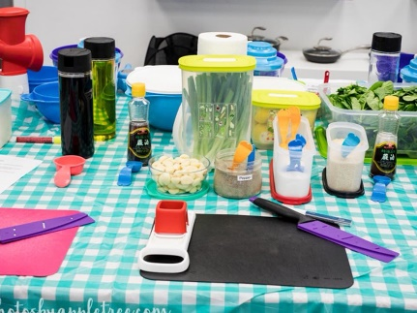

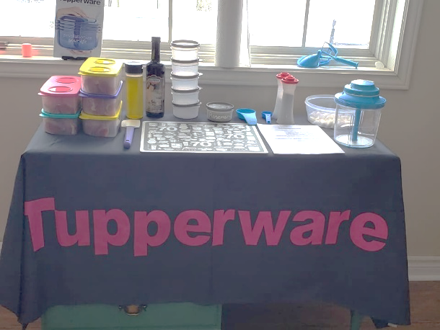**Sample Menu**  
Grilled Hawaiian Chicken  
  
Brown Sugar Balsamic Pork  
  
Asparagus Stuffed Chicken Breast  
  
Easy Crockpot Mongolian Beef  
  
Spinach & Ricotta Stuffed Shells

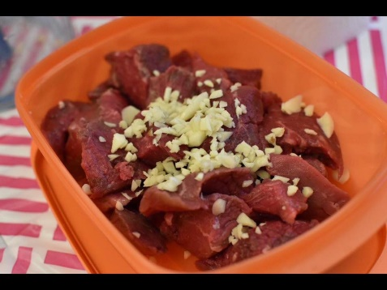***With over 75 meals to choose from, we make customizing your 5 meals simple.***

***Invite your friends and family over, and enjoy free gifts and half off items!***

